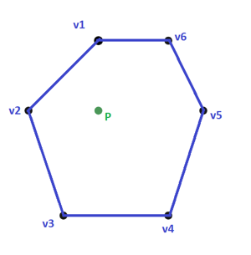

MV Coordinates are:

MV 1: 24.8674

MV 2: 30.2576

MV 3: 13.4547

MV 4: 9.99049

MV 5: 11.1294

MV 6: 10.3004

[(3,8), (1,6), (2,3), (5,3), (6,6), (5,8), P(3,6)]

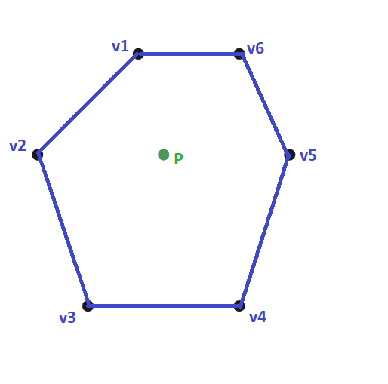

MV 1: 22.8028

MV 2: 20.9293

MV 3: 12.4685

MV 4: 12.4685

MV 5: 16.7282

MV 6: 14.6027

[(3,8), (1,6), (2,3), (5,3), (6,6), (5,8), P(3.5,6)]

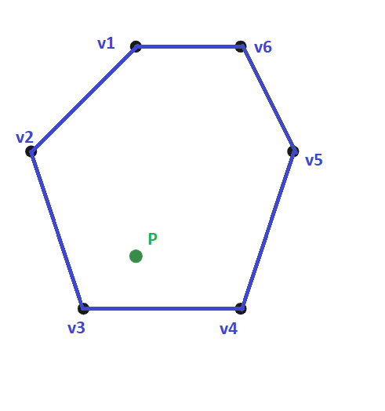MV 1: 4.54423

MV 2: 13.9762

MV 3: 47.1882

MV 4: 24.5982

MV 5: 6.55782

MV 6: 3.13537

[(3,8), (1,6), (2,3), (5,3), (6,6), (5,8), P(3,4)]

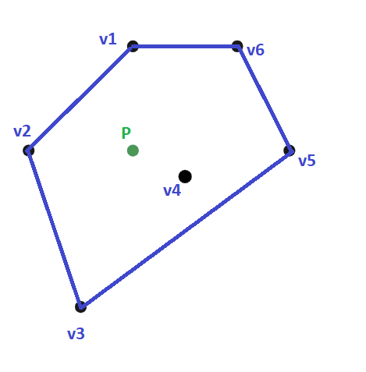

MV Coordinates are:

MV 1: 19.828

MV 2: 24.1259

MV 3: 14.0818

MV 4: 27.6731

MV 5: 6.07818

MV 6: 8.21302

[(3,8), (1,6), (2,3), (4,5.5), (6,6), (5,8), P(3,6)]

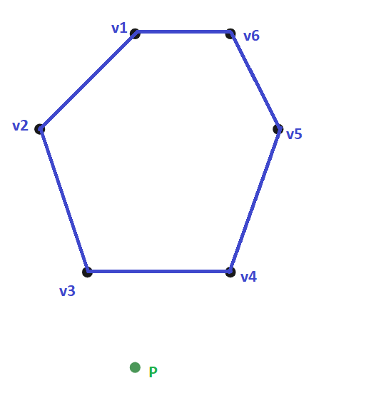MV 1: 6.91595

MV 2: 6.32884

MV 3: 44.2047

MV 4: 30.7527

MV 5: 6.36275

MV 6: 5.43504

[(3,8), (1,6), (2,3), (5,3), (6,6), (5,8), P(3,1)]